AICTE REPORT

NAME: SIRI M V

USN :1SI21EI040

SEM :5TH SEM EIE BRANCH

# ACTIVITY 1: Agricultural and industrial exhibition siddaganga matt

|  |  |  |  |
| --- | --- | --- | --- |
| START DATE | 08/2/23 | END DATE | 22/02/2023 |

15 days activity : volunteering in explaining the project called “ Design of SCADA using labview &microntroller monitoring greenhouse parameter”

# Daily 4 hours activity for 15 days

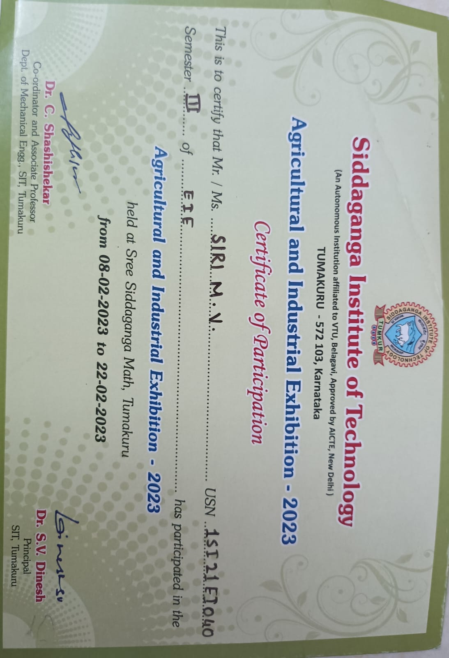

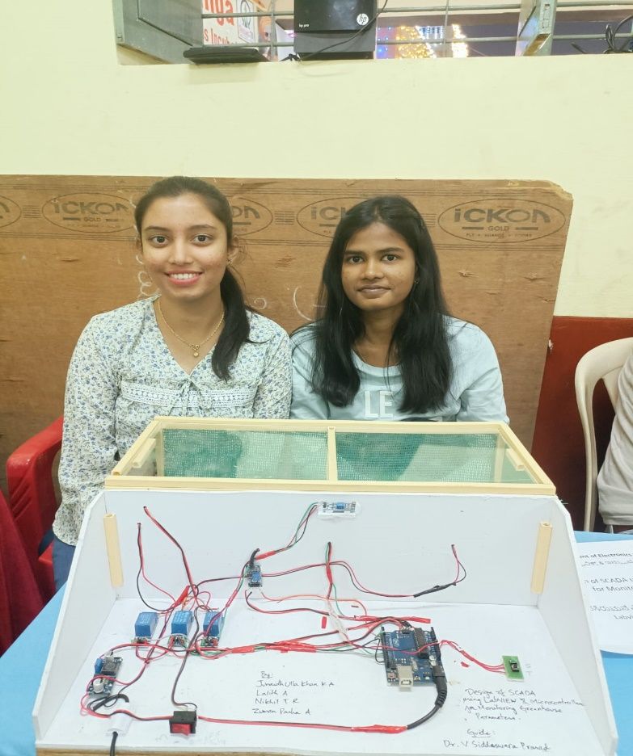

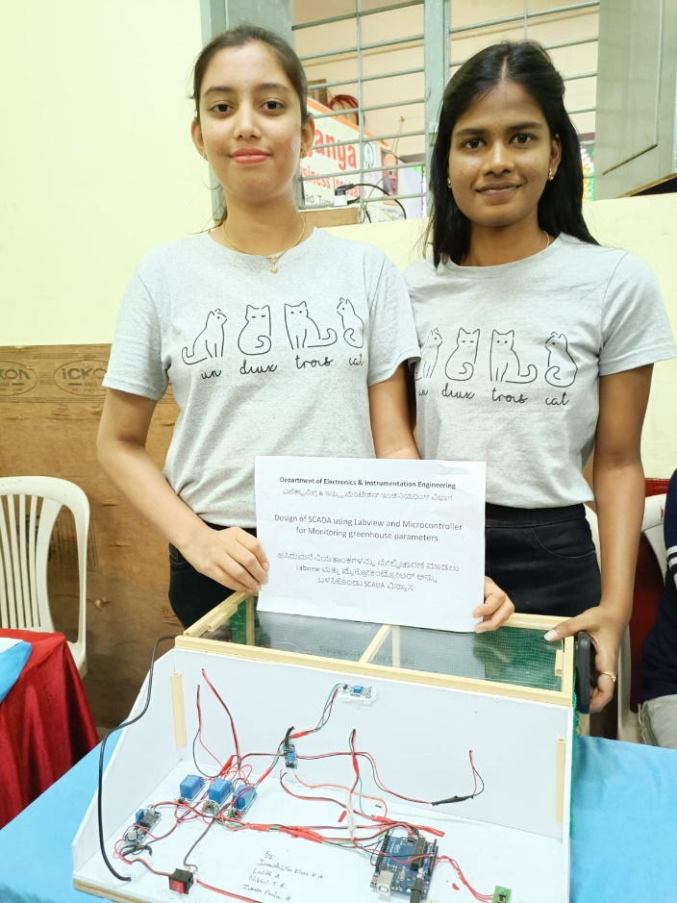

**Activity 2: Helping Local Schools to Achieve Good Result and Enhance Their Enrolment in Higher/ Technical**

# SCHOOL 1: Shree Shiva Ashrama Primary And High School.

OBJECTIVES:

1. Conducting co-curricular activities such as essay writing and debate to improve their communication skills.
2. Guiding high school students regarding career opportunities
3. Encouraging students to perform better in exams without any fear.
4. Educating students to avoid taking junk food.
5. Educating the students about the cleanliness and also importance of first aid by giving the kit.
6. Encouraging students to perform better in exams without any fear.

NUMBER OF STUDENTS: 40 minimum in a class.

# START DATE :30/11/23 END DATE : 10/01/2024

